SCHOOL OF COMPUTER SCIENCE AND ARTIFICIAL INTELLIGENCE |  |  |  |  | DEPARTMENTOF COMPUTER SCIENCE ENGINEERING
ProgramName:M. Tech/MCA/MSC |  |  |  | AssignmentType: Lab |  |  | AcademicYear:2025-2026
CourseCoordinatorName |  |  |  | Venkataramana Veeramsetty
CourseCode |  |  |  | CourseTitle |  | AI Assisted Problem Solving Using Python
Year/Sem |  |  | II/I | Regulation |  | R24
DateandDay  of Assignment |  |  | Week5- Monday | Time(s)
Duration |  |  | 2 Hours | Applicableto  Batches
AssignmentNumber:11.3(Presentassignmentnumber)/24(Totalnumberofassignments)
 | Q.No. | Question |  |  |  |  |  | ExpectedTime  to complete

E | 1 | Lab 11 – Data Structures with AI: Implementing Fundamental Structures  Lab Objectives  - To implement fundamental data structures with the assistance of AI tools.  - To understand how AI suggests different implementations and optimizations.  - To analyze the readability, correctness, and performance of AI-generated code.  - To reinforce problem-solving skills using AI-powered coding assistance.  Learning Outcomes  After completing this lab, students will be able to:  - Implement stack, queue, and linked list using Python with AI support.  - Use AI tools to optimize and refactor basic data structure operations.  - Compare multiple AI-suggested implementations for the same structure.  - Apply AI assistance to generate test cases for verifying data structure behavior.  - Demonstrate understanding of trade-offs in AI-generated solutions.  Task Description #1 – Stack class implementation  Task: Ask AI to implement a stack class with push(), pop(), peek() and is_empty() methods  Prompt: Generate python function to implement a stack class with push(), pop(), peek() and is_empty() methods.  Code:  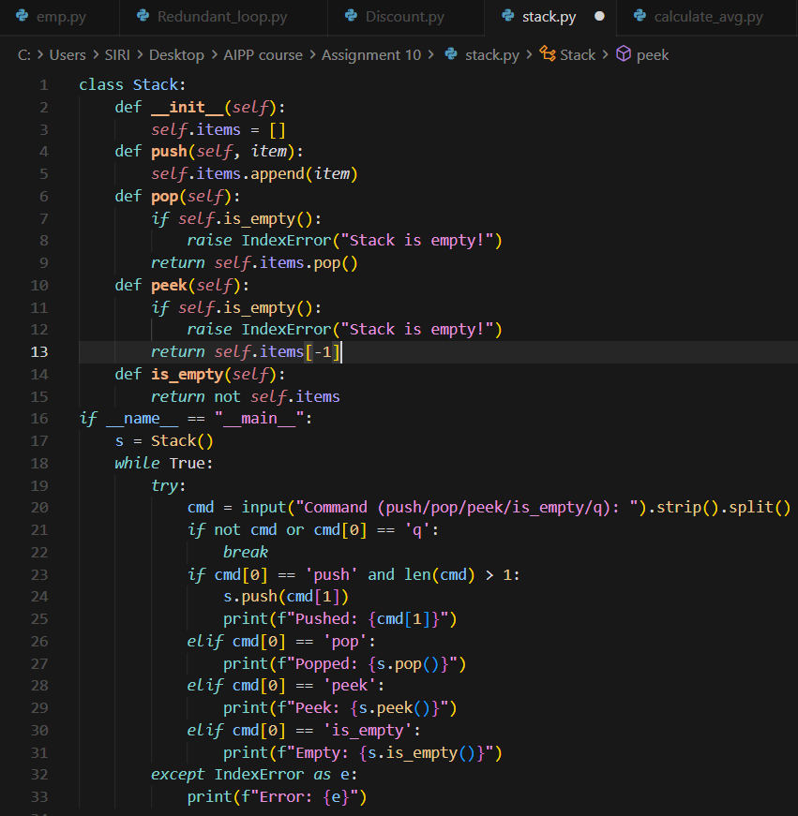  Code Explanation:  - The Stack class stores elements in a list and provides basic stack operations like push, pop, peek, and checking emptiness.  - The push method adds a new item to the top of the stack, while pop removes and returns the last pushed item.  - The peek method returns the top element without removing it, and both pop and peek raise an error if the stack is empty.  - The is_empty method returns True when the internal list has no items.  - In the main loop, the program takes user commands, performs stack operations accordingly, and handles empty-stack errors using try-except.  Output:  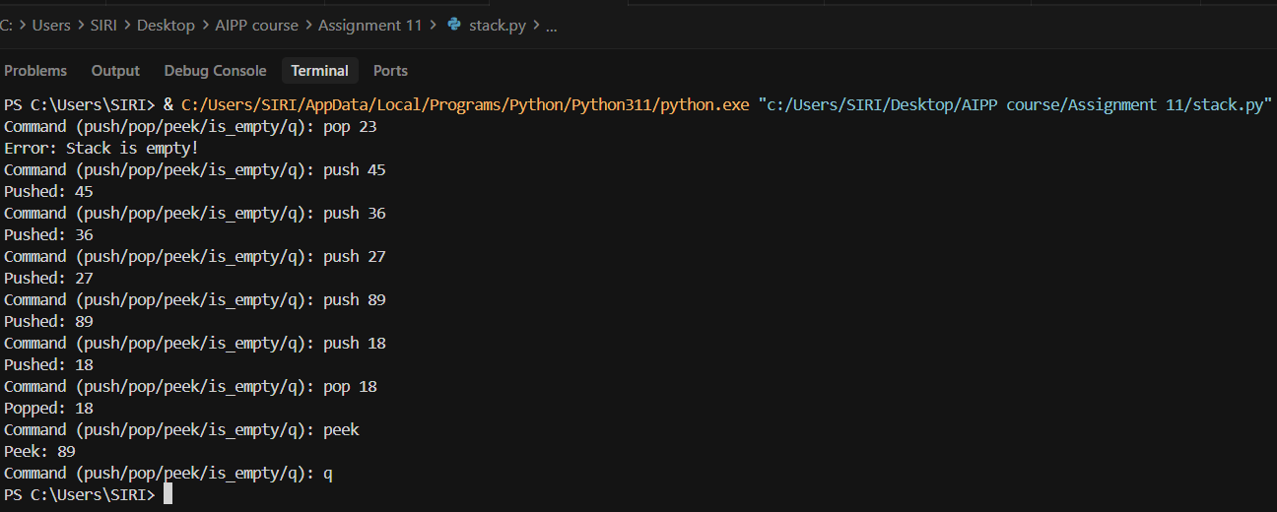  Task Description #2 – Queue Implementation  Task: Use AI to generate a Queue class with enqueue(), dequeue(), and is_empty().  Prompt: Generate a python function to implentQueue class with enqueue(), dequeue(), and is_empty().  Code:  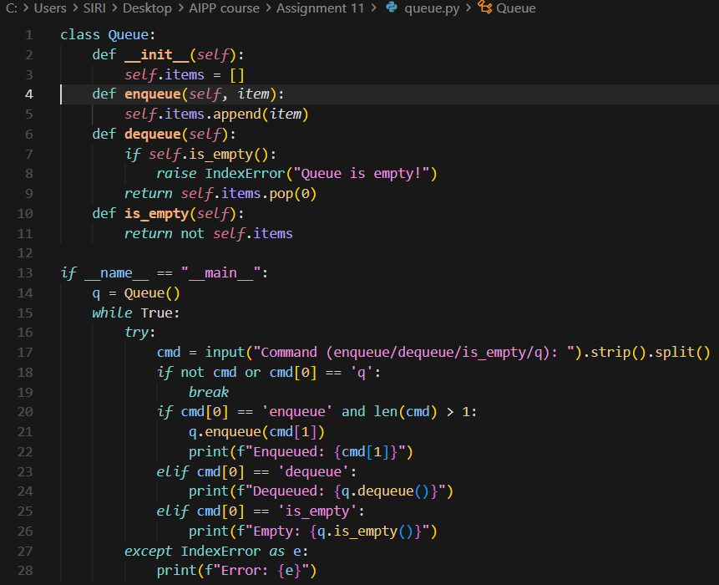  Code Explanation:  - The Queue class uses a Python list to store elements and provides basic queue operations.  - The enqueue method adds a new item to the end of the queue.  - The dequeue method removes and returns the first inserted item, and raises an error if the queue is empty.  - The is_empty method checks whether the queue has any elements.  - In the main loop, the program reads user commands, performs queue operations, and handles empty-queue errors using try-except.  Output:  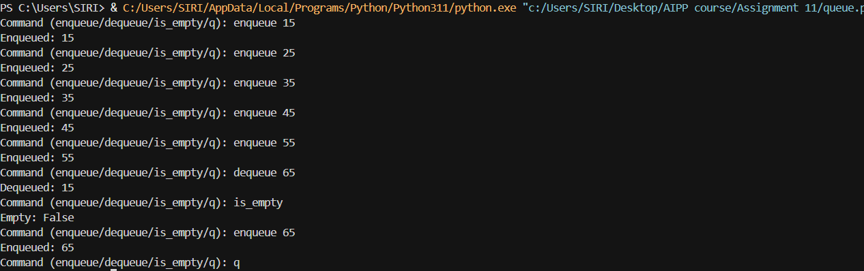  Task Description #3 – Linked List Implementation  Task: Ask AI to create a singly linked list with insert_at_end(), insert_at_beginning(), and display().  Prompt: Generate a python function to create a singly linked list with insert_at_end(), insert_at_beginning(), and display().  Code:  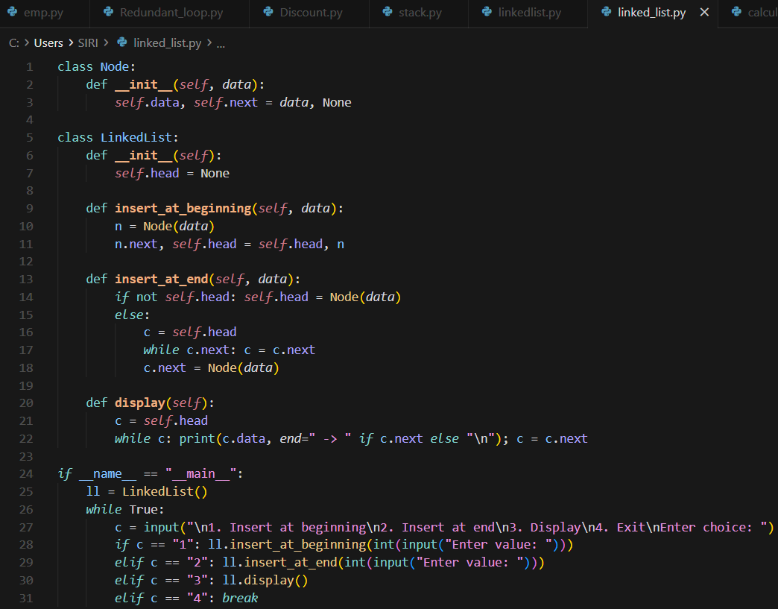  Code Explanation:  - Node class stores one value and a pointer to the next node in the linked list.  - LinkedList starts with an empty head, meaning no elements initially.  - insert_at_beginning() creates a new node and makes it the new head by linking it before the current list.  - insert_at_end() traverses to the last node and attaches a new node at the end of the list.  - display() walks through the list and prints all nodes, and the main loop lets the user choose operations interactively.  Output:  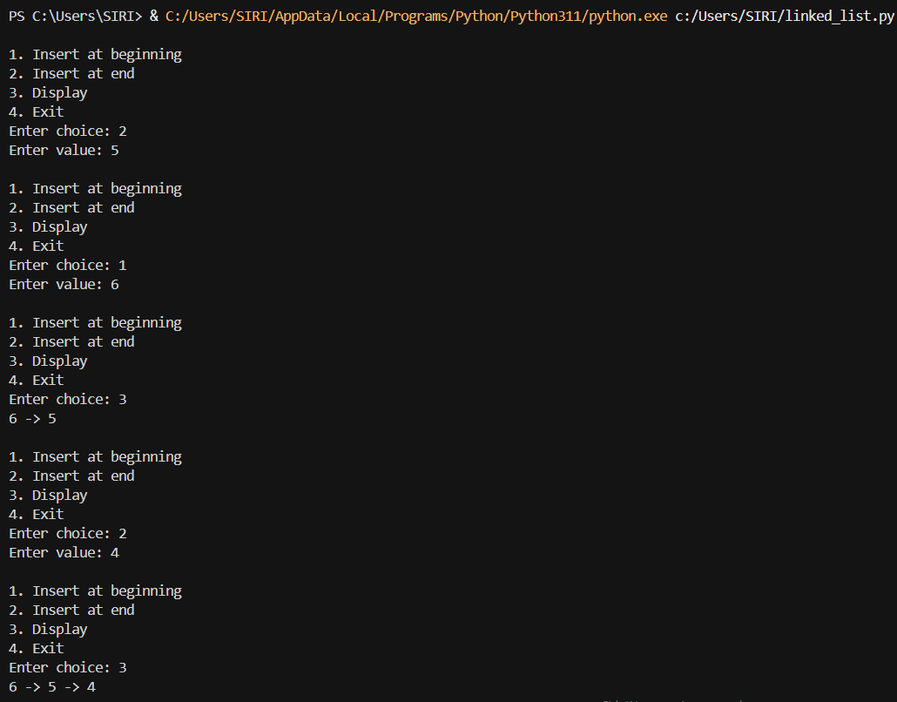  Task Description #4 – Binary Search Tree (BST)  Task: Ask AI to generate a simple BST with insert() and inorder_traversal().  Prompt: Generate a python function to generate a simple BST with insert() and inorder_traversal().  Code:  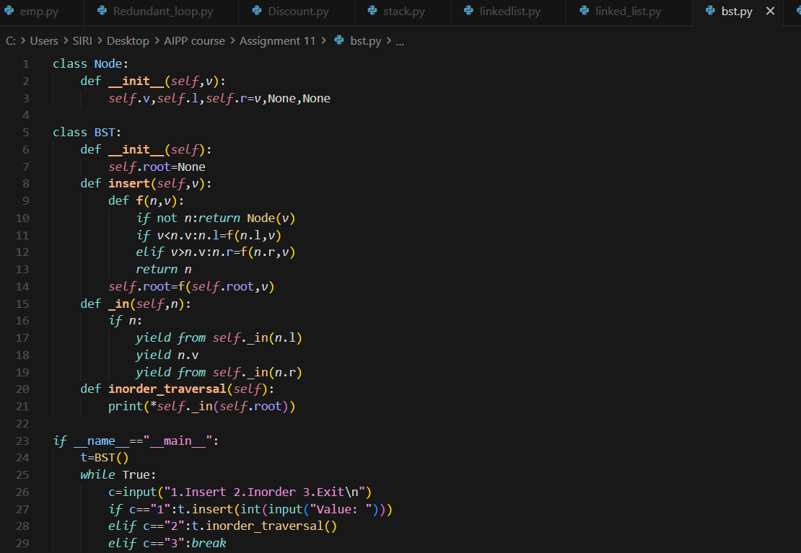  Code Explanation:  - Node stores a value and two child links (left and right) used to build the BST structure.  - BST starts empty, and the insert() function recursively finds the correct position for the new value.  - Smaller values go to the left child, larger values to the right, maintaining the BST rule.  - Inorder traversal visits left → node → right, which prints the values in sorted order.  - Main loop lets the user insert values and display the BST using inorder traversal until they choose to exit.  Output:  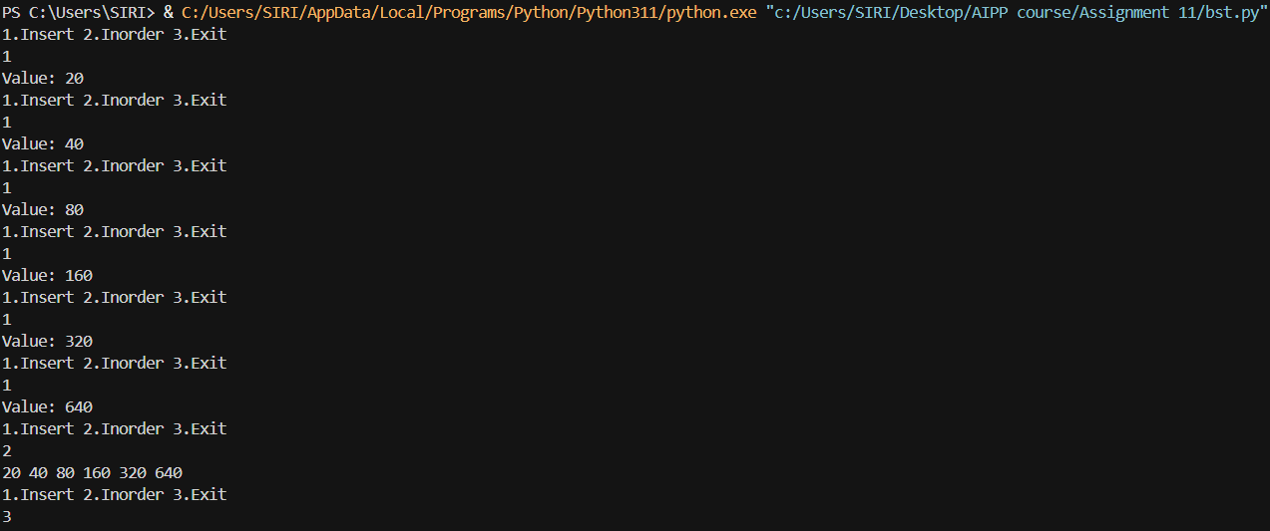 | Week5 - Monday

